PYTHON ASSIGNMENT 2
Please find below the screenshots of output of 4 files
1. File: SBC009.txt
2. File: SBC022.txt
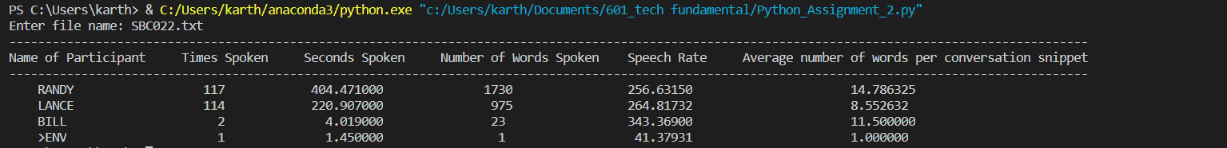
3. File: SBC037.txt
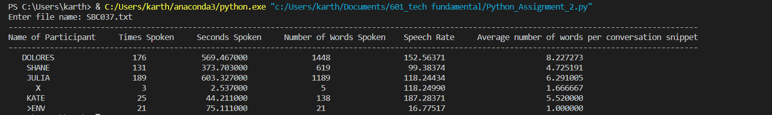
4. File: SBC059.txt
